Digital Forensics  Diploma in CSF/IT  Year 2/3 (2025/26) Semester 4/6 | Week 7
 | Practical 7
NTFS Analysis

OBJECTIVES

To be able to:
- Navigate to the $MFT entry from the PBR in an NTFS partition.
- Interpret the $MFT structure.

Steps: (You may follow the detailed steps in Practical 7)

- Start a new case in EnCase and name it as NTFS Analysis.
- Add Laura’s evidence file to the case.
- Switch to Disk view.
- Go to Physical Sector 2048, or the first logical sector of the first NTFS partition.

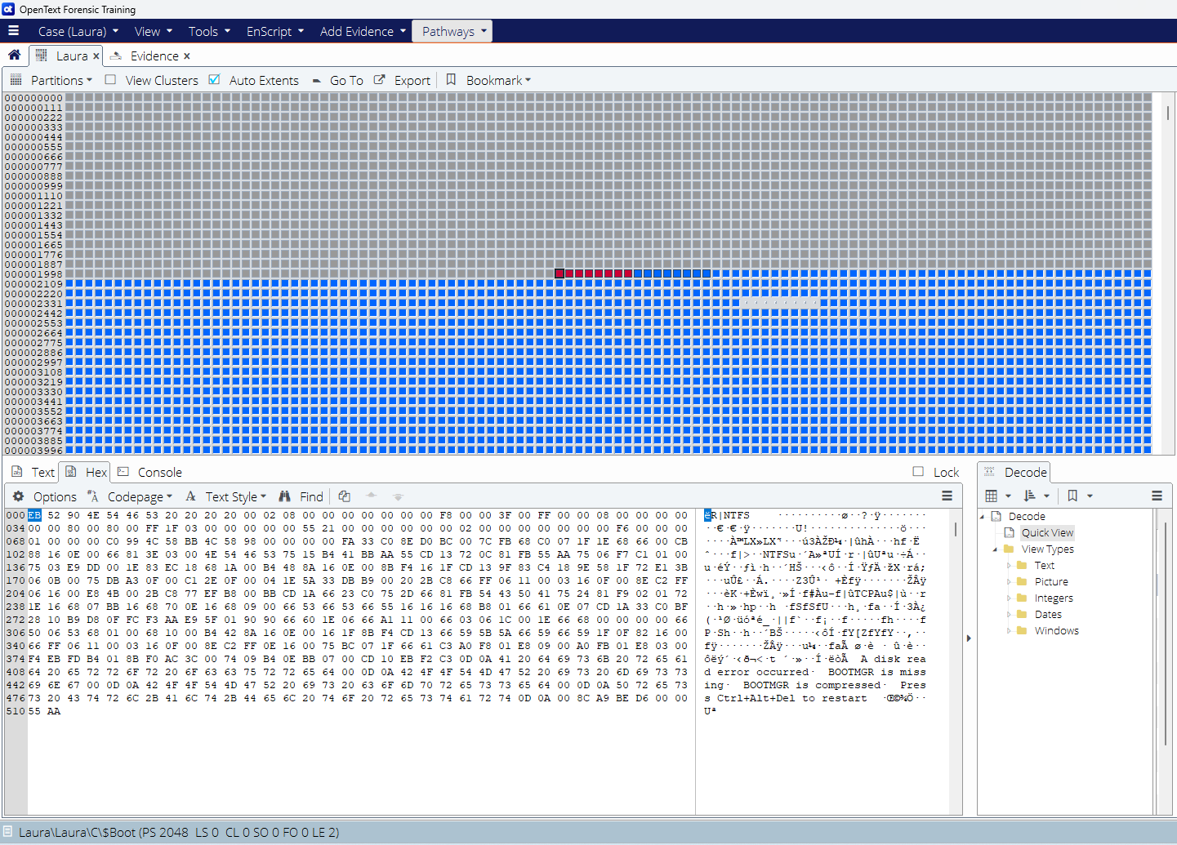
Figure 1: Physical Sector (PS) 2048

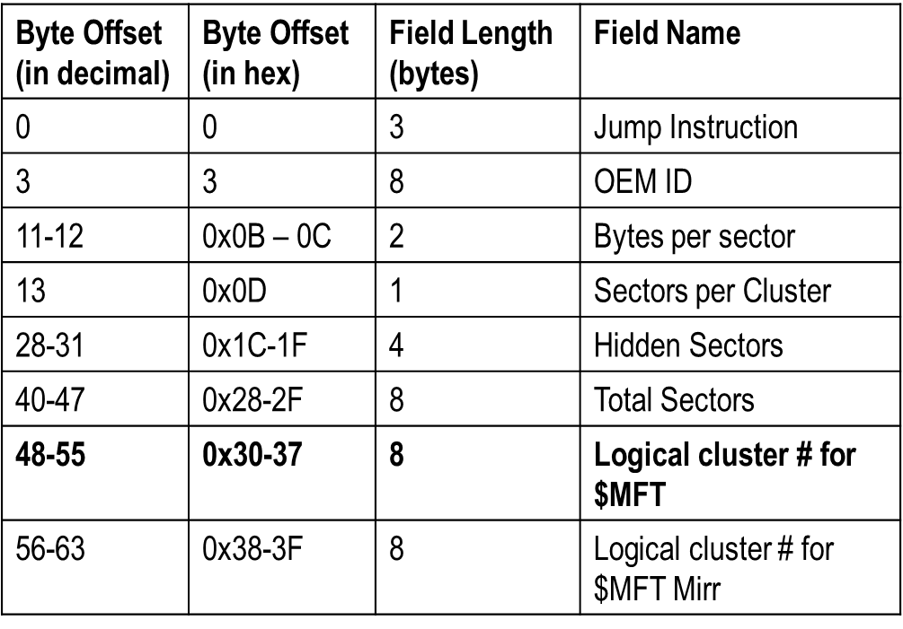
Table 1: Partition Boot Record (PBR)

With reference to Table 1 above, answer the following:

Q1: What is Original Equipment Manufacturer Identifier (OEM ID)? How many Bytes per Sector? How many Sectors per Cluster? What is the Logical cluster number for $MFT?

- Now, from Disk view, select View Clusters.

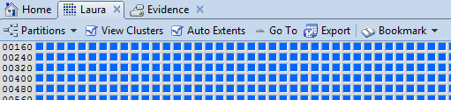
Figure 2: View Clusters

- Right-click, select Go To and enter 8533 to view $MFT table.

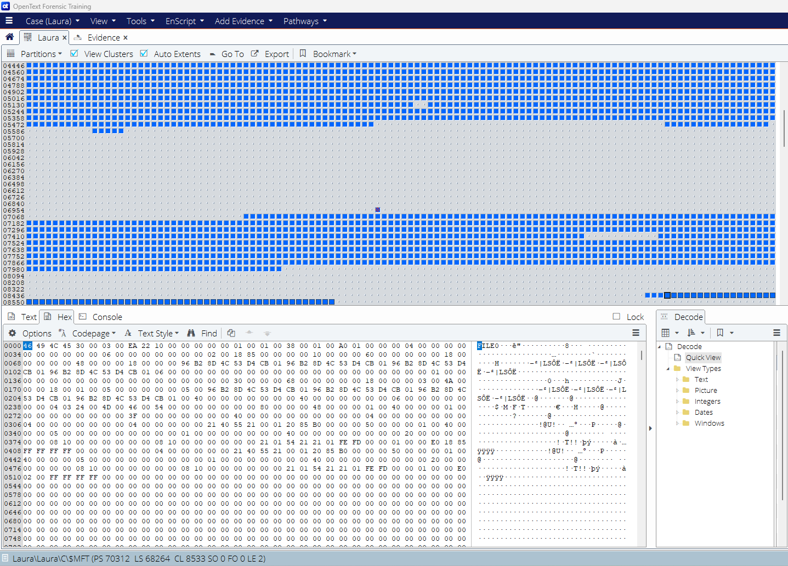
Figure 3: $MFT Entry

All MFT records follow the same structure. They are 1024 bytes in size, and start with a 48-byte header section and an 8-byte Fixup array. At offset 0x38 (48+8=56 (or 38 in hex)) is the start of a string of attributes. The header describes the properties of the record, and the attributes describe all aspects of the file from its name to its data.

- Go to sector offset 56 (0x38) in the View pane, which is the start of first attribute. The first MFT record is $MFT table.

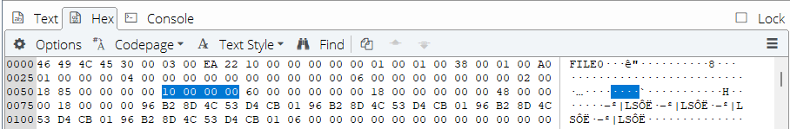
Figure 4: First Attribute

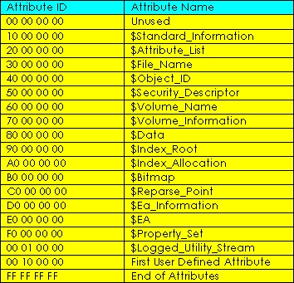
Table 2: NTFS Attributes

Q2: Complete the following for the first attribute of $MFT record.

Q3: How would you go to the 2nd attribute? Use Appendix A for hex to decimal conversion if necessary.

Q4: Complete the following for the 2nd attribute of $MFT record.

Q5: Go to 3rd attribute. Complete the following for 3rd attribute.
(To go to 3rd attribute: 0x98+0x68 = 0x100 (or 256 decimal))

Q6: Consolidate your findings above and complete the following diagram to show the composite of $MFT entry:

Length: 1024 bytes

$ MFT Entry Header

$ File_Name
$ Data

$ Standard_Information

- The End -

Appendix A – Hexadecimal-to-Decimal Conversion Table

